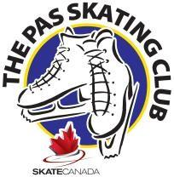
The Pas Skating Club
2023 -2024

Pre-Season CanSkate Program

The Pre-season CanSkate Program is a learn-to-skate program designed to develop basic skating skills for skaters to carry on into hockey or figure skating this season. CanSkate targets children, ages 5 to 12, who either have no skating experience or some skating experience (can stand and glide). Skaters develop fundamental skating movements, play games to practice skills and receive badges as they progress through stages and skills. The program concludes with a session end report. Skaters in CanSkate must wear hockey skates or figure skates and a helmet (CSA-approved hockey helmet). Each session is 45 minutes in length.

Location: RHJ Arena

Schedule:

Wednesday, September 6 to Friday, September 8 | 4:30 pm – 5:15 pm
Saturday, September 9  Monday September 11 to Friday, September 15 | 11:00 - 11:45 am  4:30 - 5:15 pm
Saturday, September 16 | 11:00 - 11:45 am

Schedule is subject to change. Please check The Pas Skating Club bulletin board at the rink for updated changes, or the Club website.

www.skatethepas.uplifterinc.com

Skate Canada Professional Coach: Janet Hallegrimson
Skate Canada Professional Assistant Coach: Autumn Snow

Cost: $90 program + $58.70 Skate Canada Insurance + $20 Fundraising Fee = $168.70 Total

